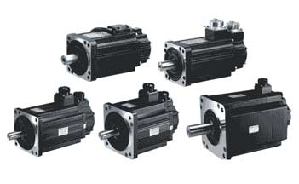
SJT SERVO MOTOR
CHARECTERISTICS
- Impressive outline and compact configuration, with totally enclosed aluminum housing applied
- Low electromagnetic noise, steady running and high efficiency, with optimal electromagnetic design applied
- Excellent low speed characteristic and strong overload capability, with high performance rare-earth permanent-magnet material employed
- Employed with high speed, high precision photoelectric encoder, which can be used for high precision speed and position control if matched with a high performance driver
- Reliable use under the -15 ~ 40 ? ambient temperatures as well as dust and oil fog environment, with F insulation degree and IP65 protection degree applied
- Reliable stability, little vibration and low noise of motor run within a high speed range, with imported high precision bearings and high precision rotor dynamic balance processing employed
- Rapid response capability by large torque inertia ratio
- High performance-cost ratio with shock-resistance and long life

TECHNICAL SPECIFICATIONS
80SJT Series Motor Technical parameters
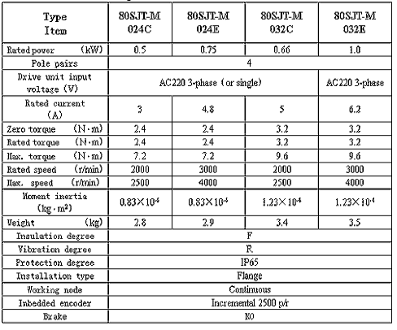

110SJT Series and 130SJT Series Motor Technical parameters(1)

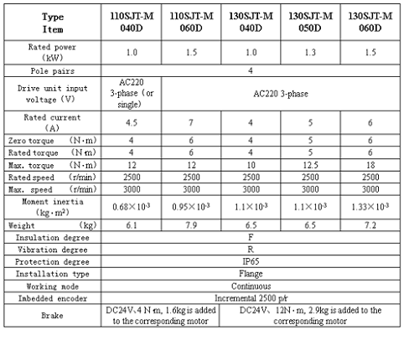

110SJT Series and 130SJT Series Motor Technical Parameters(2)

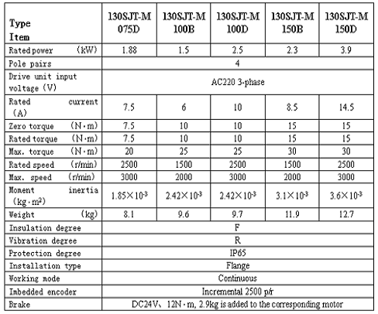

175SJT Series Motor Technical parameters
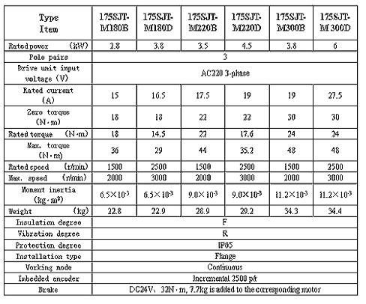

80SJT Series Motor Installation Dimension
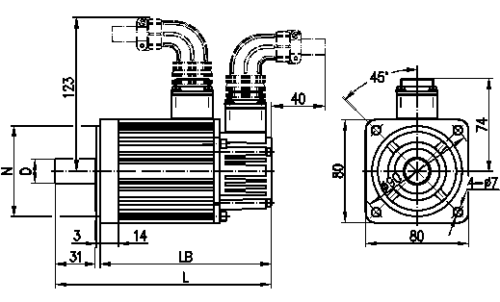

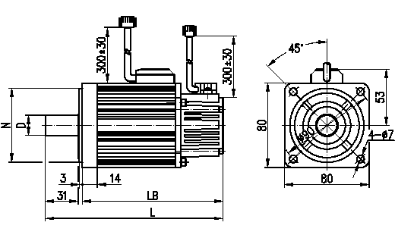
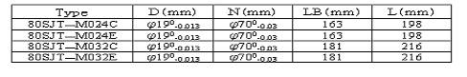
110SJT Series Motor Installation Dimension
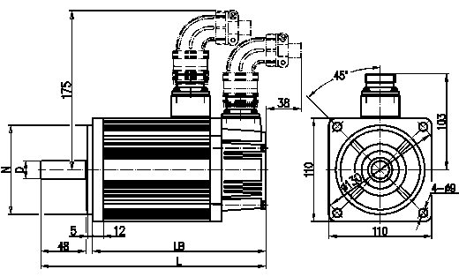

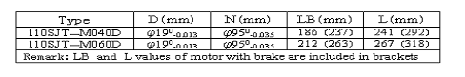

130SJT Series Motor Installation Dimension
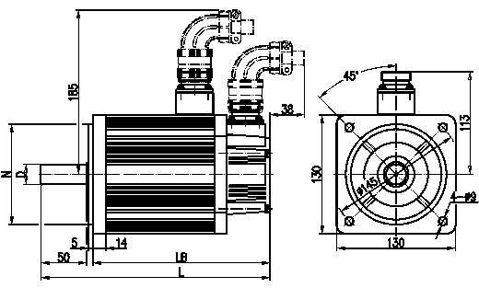

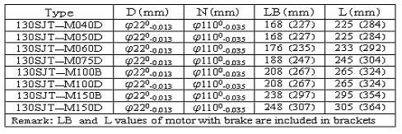

175SJT Series Motor Installation Dimension
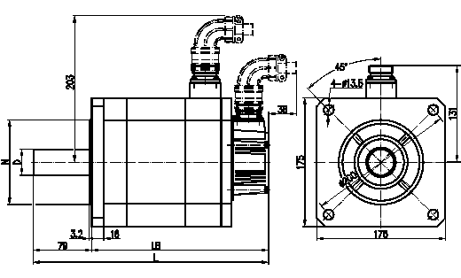

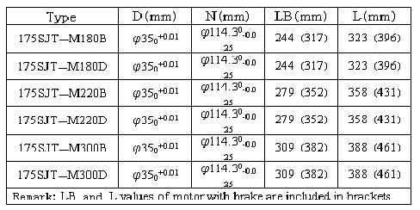
Motor Mechanical Characteristic Curve
